Press Release
Diepoldsau, March 2024
Noventa AG and Swiss Solar City AG Launch Collaboration for Sustainable Energy
Diepoldsau, Switzerland
Noventa AG has launched a new industrial solar system in a long-term partnership with Swiss Solar City AG, a specialist in comprehensive solar solutions. This collaboration marks a significant step forward in the use of renewable energies and underscores the commitment of both companies to sustainable development and innovation.
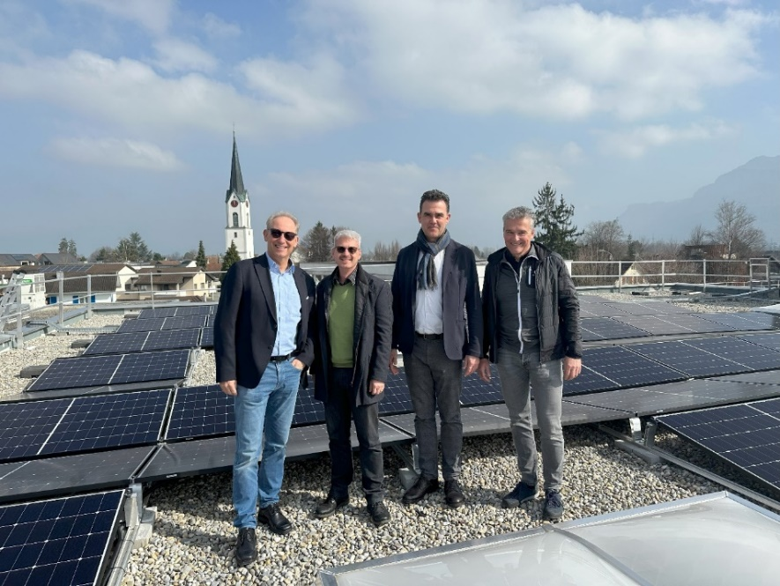
The new solar system, strategically installed on the flat roofs of Noventa AG, consists of 577 solar modules with a total output of 250 kWp, making a significant contribution to energy efficiency and reducing the company's carbon footprint. This solar system is not only a technological masterpiece but also a prime example of smart energy contracting, as Noventa was able to significantly reduce its own investments through the cooperation with Swiss Solar City while still retaining full control over its facilities.
Group from left to right: Noventa AG: Board Member Reinhard Maurer, Magnefico GmbH: Alain Schilli, Swiss Solar City: Board Member Stephan Ensmann, Noventa AG: Project Manager Daniel Köppel.

About Swiss Solar City
Swiss Solar City is an independent, dynamic company from Switzerland, specializing in the provision of comprehensive solar solutions for industry and commerce. With one of the largest photovoltaic plant portfolios in Switzerland, Swiss Solar City offers its customers individually tailored, environmentally friendly, and economically advantageous solutions.
About Noventa AG
Noventa AG is a management-led technology company based in the St. Gallen Rhine Valley, specializing in the development and manufacturing of plastic components, functional assemblies, and complete product systems since 1994. With locations in Switzerland, Romania, and Thailand and a team of around 800 employees, Noventa strives for the highest quality and innovative solutions for customers worldwide.

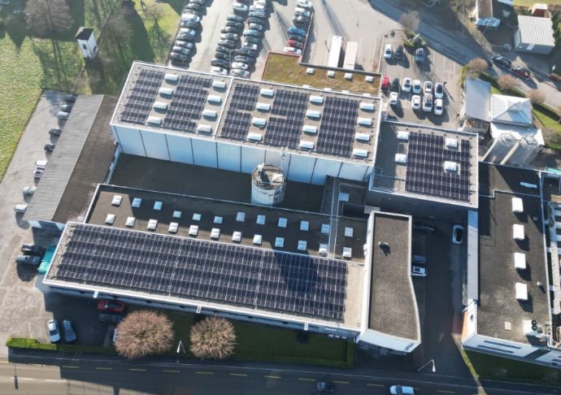
Facts and Figures of the Swiss Solar City Solar System
Location | CH-Diepoldsau
Type of Rppf | Flachdach
Number of Modules | 577
Output | 250 kWp
Yield | 261'298 kWh

Aerial photograph Noventa AG, solar modules.

For further information, please contact:
Noventa AG  Martina Baldauf  Marketing Communications  media.ch@noventa.com  T +41 71 737 95 16 | Swiss Solar City AG  Stephan Ensmann  Business Development  stephan.ennsmann@swiss-solar-city.ch  T +4158 255 04 25

Keywords: Noventa AG, Swiss Solar City AG, Industrial Solar Systems, Solar Contracting

