Press Release
Diepoldsau, July 2023
An opportunity for further development: Second visit of Takeda Hitoshi, the Master of Lean Management, at Noventa AG
Diepoldsau, Switzerland. We are pleased to continue our partnership with Takeda Hitoshi, a globally recognized pioneer of Lean Management. On July 6, 2023, we had the chance to welcome Takeda once again to our production facilities in Diepoldsau. This visit marks a significant milestone in our ongoing pursuit of excellence and continuous improvement within the principles of Lean Management.
Noventa AG: Efficient Operations and Global Success through Lean Management
As a technology company successfully operating since 1994, Noventa has an impressive history of developing and implementing innovative products for the global market. However, it was the implementation of Lean Management principles that allowed us to conduct sustainably efficient and profitable operations. With a strong presence in Switzerland and branches in Thailand and Romania, we are able to provide our customers in different industries with holistic solutions along their individual value chains. Our corporate culture is deeply rooted in the principles of Lean Management, which make a crucial contribution to our success, particularly in the areas of product development, production and assembly.
Takeda's Synchronous Production System
For over 30 years, Takeda has been working with companies around the world, imparting his unique concept of the "Synchronous Production System". His approach, characterized by long-term orientation, has helped numerous companies optimize their operations and reach the top in their respective industries. With his second visit to our facilities, we at Noventa underscore our commitment to these proven management methods.
Insights and Perspectives
His visit has given us valuable insights and perspectives for improvements. Takeda is known for his deep respect for employees and his belief that process improvements should never be used as justification for mass layoffs - an attitude that we at Noventa share and promote.
As part of our constant efforts for further education and improvement, we look forward to integrating the lessons learned into our work processes and continuing to provide our customers with high-quality products and services.
Invitation to Experience
If you are interested in Lean Management and continuous improvement, we invite you to an exchange of experiences. Stay tuned for more updates on our exciting partnership with Takeda Hitoshi and our ongoing journey to operational excellence.

Keywords: Lean Management, Takeda Hitoshi, continuous improvement, Noventa AG, Synchronous Production System, operational excellence.

Numbers and Facts Noventa AG
Products and Services: | Product Development: Product conception, product design, development/engineering, electronics development, prototyping  Production: Part manufacturing/plastic injection molding, tool making, device assembly, procurement, logistics, quality assurance
Locations: | Headquarters in Switzerland, production in Romania and Thailand
Employees: | Approximately 240

Photographic Material
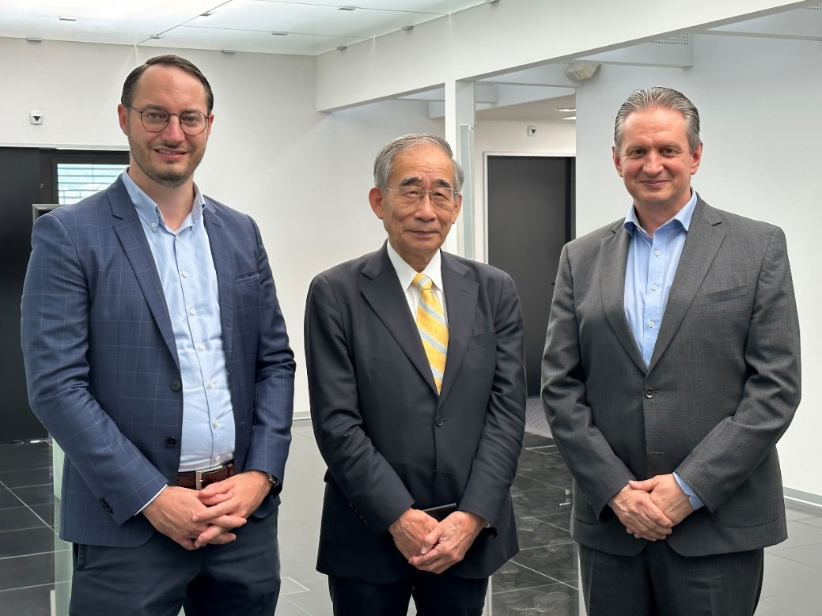
v.l.n.r. Julian Mundl/CEO Noventa Consulting AG, Hitoshi Takeda/SPS Management Consultants, Anis Rifai/CEO Noventa AG
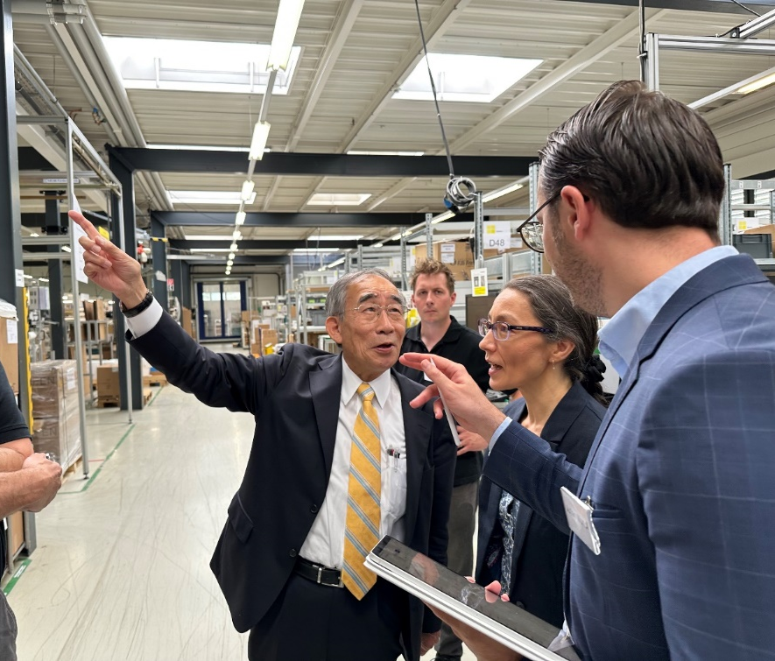
Hitoshi Takeda, Company visit to Noventa AG, 06.07.2023
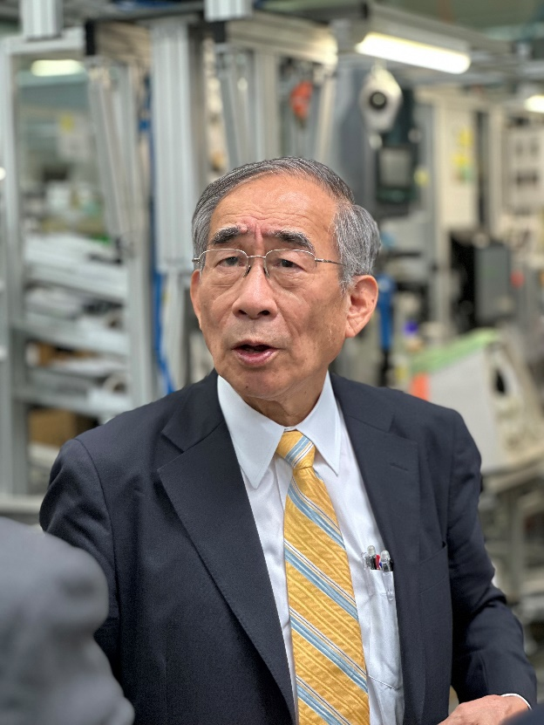
Hitoshi Takeda, Company visit to Noventa AG, 06.07.2023
Contact and inquiries:
Noventa AG
Martina Baldauf
Marketing Communications
media.ch@noventa.com
T +41 71 737 95 16

